Sprint 2 - Accuracy Design Document

November 18, 2021

Table of Contents

1. Executive Summary 4

1.1 Project Overview 4

1.2 Purpose and Scope of this Specification 4

2. Product/Service Description 4

2.1 Product Context 4

2.2 User Characteristics 4

2.3 Assumptions 4

2.4 Constraints 4

2.5 Dependencies 5

3. Requirements 5

3.1 Security 6

3.1.1 Protection 6

NA 6

3.1.2 Authorization and Authentication 6

NA 6

3.2 Portability 6

4. Requirements Confirmation/Stakeholder sign-off 6

5. System Design 6

5.1 Algorithm 6

5.2 System Flow chart 7

5.3 Software 8

5.4 Hardware 8

5.5 Test Plan 8

5.6 Task List/Gantt Chart Made by Anthony Pastorelli 8

5.7 Block code 9

5.8 11

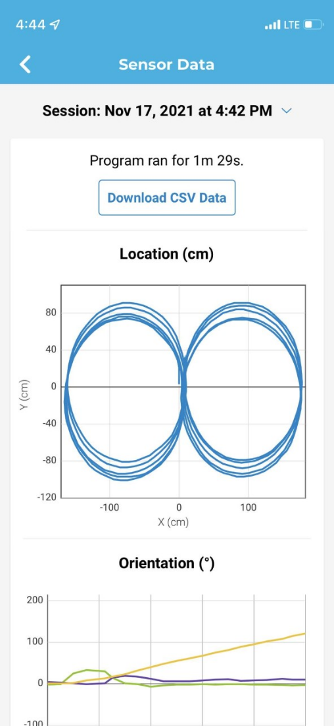 11

5.9 Staffing Plan 11

# **Executive Summary**

## Project Overview

**This Project was made as a computer science project by Jenna Esposito (manager), Therese Racancoj (editor) and Anthony Pastorelli (Chart Maintenance). The purpose of the project is to test the robot and see if it will follow the commands we program into it, which is to follow the blue tape that has been on ground in the shape of a figure eight.**

## Purpose and Scope of this Specification

In scope

* Figer 8 courses

Out of Scope

* Other courses

# **Product/Service Description**

## Product Context

**This is one of three parts of the Robotics Triathlon**

## User Characteristics

* **Team members**

## Assumptions

**The class room was assumed to be available when team members needed it**

**Team members were assumed to have similar schedules**

**This project was expected to take less time than the first one**

## Constraints

* **The tile in class room 208 is uneven**
* **The tape does not always stay down**
* **Teammates have conflicting schedules**
* **Class room 208 is not always available**
* **The two circles are not the same size**

## Dependencies

* **This program must be run in class room 208**
* **Requirements must be finished before the coding process can begin**
* **Must be placed on the blue tape figure 8**

# **Requirements**

* **Robot must travel along the figure 8 course the robot must travel along the figure 8 course**
* **Robot must go around the course 5 times the robot must travel along the figure 8 course 5 times**
* **Robot must say “I am the winner” when the code is run it should say I am the winner**
* **Flash multicolored lights for 5 seconds at the end the robot must change different colors for 5 seconds at the end**
* **Robot must start in the center the robot must be placed in the center of the two circles**
* **Robot must end in the center the robot must stop at the center of the two circles**
  + **Functional Requirements**

| Req# | Requirement | Comments | Priority | Date Rvwd | SME Reviewed / Approved |
| --- | --- | --- | --- | --- | --- |
| **ACCURACY_1** | **Robot must travel along the figure 8 course** |  | **Priority 1** | **11/16** | **11/17** |
| **ACCURACY_2** | **Robot must go around the course 5 times** |  | **Priority 1** | **11/16** | **11/17** |
| **ACCURACY_3** | **Robot must say “I am the winner”** |  | **Priority 2** | **11/16** | **11/17** |
| **ACCURACY_4** | **Flash multicolored lights for 5 seconds at the end** |  | **Priority 2** | **11/16** | **11/17** |
| **ACCURACY_5** | **Robot must start in the center** |  | **Priority 1** | **11/16** | **11/17** |
| **ACCURACY_6** | **Robot must end in the center** |  | **Priority 1** | **11/16** | **11/17** |

## Security

### Protection

### NA

### Authorization and Authentication

### NA

## Portability

* **Testing was limited to class room 208**
* **Recording the video can only be done in class room 208**
* **Code can be done any where**

# **Requirements Confirmation/Stakeholder sign-off**

|  |  |  |
| --- | --- | --- |
| Meeting Date | Attendees (name and role) | Comments |
| **11/17/21** | **Anthony Pastorelli (Chart Maintenance), Jenna Esposito (manager), Therese Racancoj (editor)** | **All requirements approved** |

# **System Design**

## Algorithm

**Sprint: Accuracy**

**made by: Jenna**

1. Speed 60

2. Spin -360 for ___ seconds

3. Spin 360 for ____ seconds

4. Loop 5 times

5. Speak “I am the winner”

6. Flash multicolored lights for 5 seconds

7. End program

## System Flow chart

**Made by Ez Racancoj**

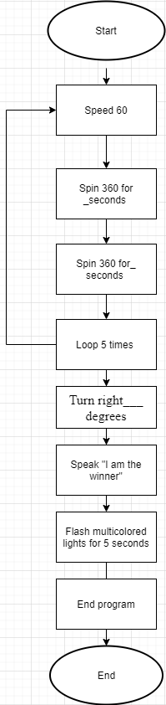

## Software

**sphero.edu app**

## Hardware

**Phone, computer and robot**

## Test Plan

| **Reason for Test Case** | **Test Date** | **Expected Output** | **Observed Output** | **Staff Name** | **Pass/Fail** |
| --- | --- | --- | --- | --- | --- |
| **Starting code** | **11/12** | **To make a circle** | **Completed a small circle** | **Anthony** | **Pass** |
| **Trying to figure out the right code to make a figure 8** | **11/12** | **To complete figure 8** | **Completed figure 8** | **Anthony** | **Pass** |
| **Fix circle size** | **11/12** | **Make circle the right size** | **Still small** | **Anthony** | **Pass** |
| **Fix circle size** | **11/16** | **Make circle the right size** | **Finally, the right size** | **Anthony** | **Fail** |
| **To get the right timing** | **11/16** | **Complete the figure 8** | **All the times seems to be good** | **Anthony** | **Pass** |
| **To complete the figure 8** | **11/17** | **Complete the figure 8** | **Finally done!** | **Anthony** | **Pass** |

## Task List/Gantt Chart Made by Anthony Pastorelli

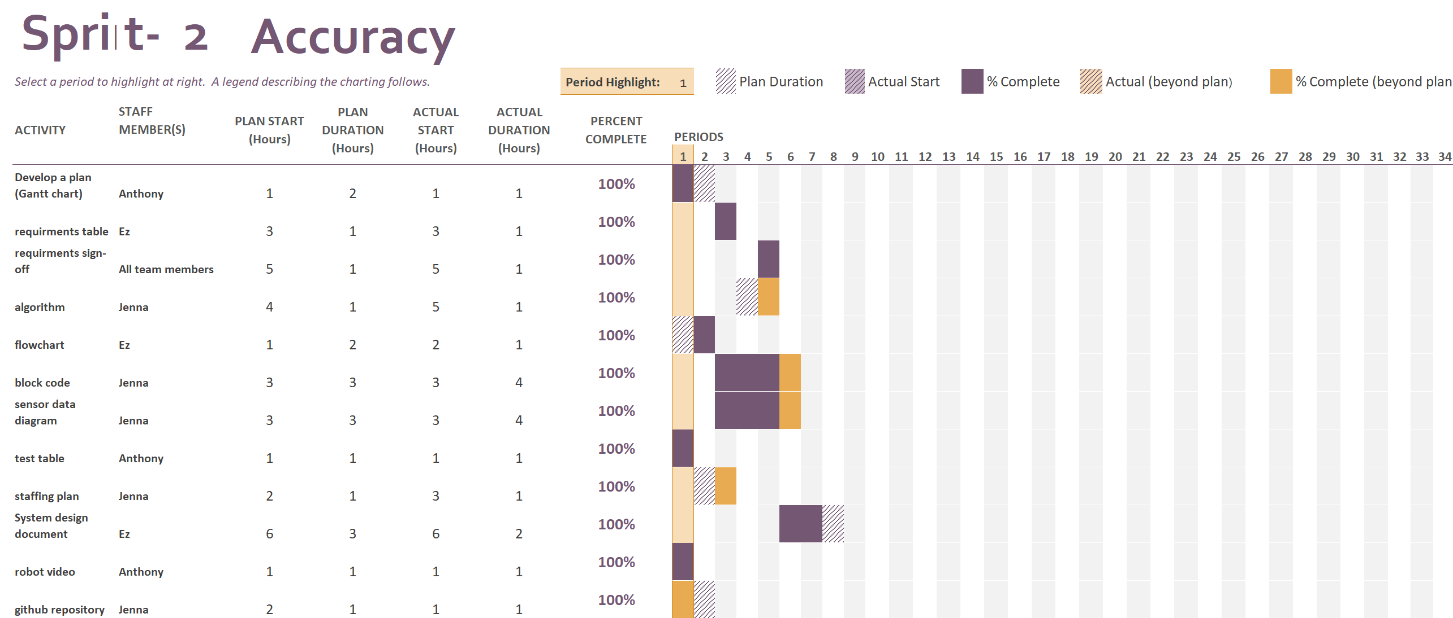

## Block code

**made by: Jenna**

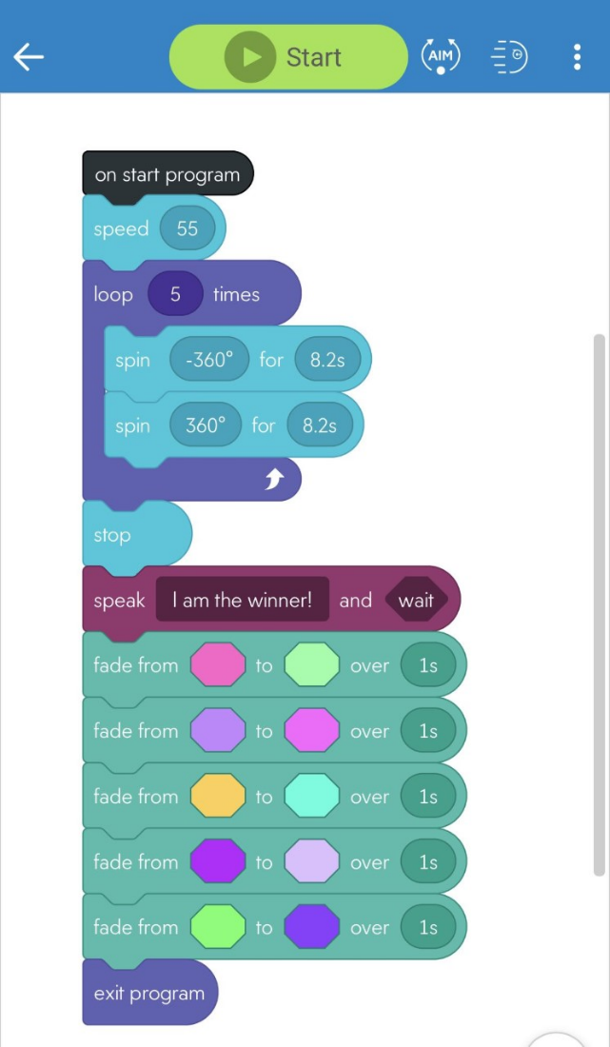

## 5.8

## 

## 5.9 Staffing Plan

| **Name** | **Role** | **Responsibility** | **Reports To** |
| --- | --- | --- | --- |
| **Jenna Esposito** | **Manager** | **Team management, organize staffing plan and deadlines, write algorithm, work with block code, and manage GitHub repository** | **Team** |
| **Ez Racancoj** | **editor** | **Editing and finalizing**  **and filling out the doc fill out requirements table, create flowchart** | **Jenna Esposito** |
| **Anthony Pastorelli** | **Chart Maintenance** | **Maintain requirements sign-off, test table, and Gantt chart and record robot video** | **Jenna Esposito** |